OPERATING SYSTEMS – CS23431

EXPERIMENT 01

1.(A) First come first serve Scheduling Algorithm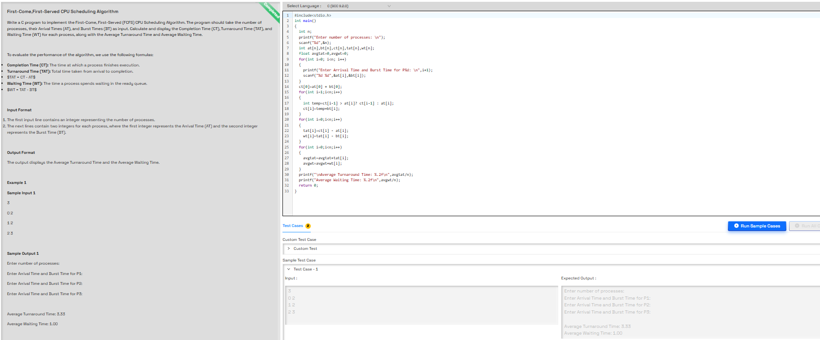
FIGURE: 1.1

1.(b) Shortest Job First Scheduling Algorithm
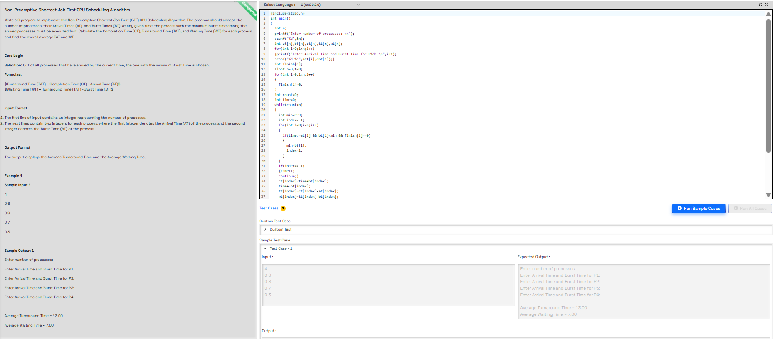
FIGURE: 1.2

1.(c) Non-Preemptive Priority Scheduling Algorithm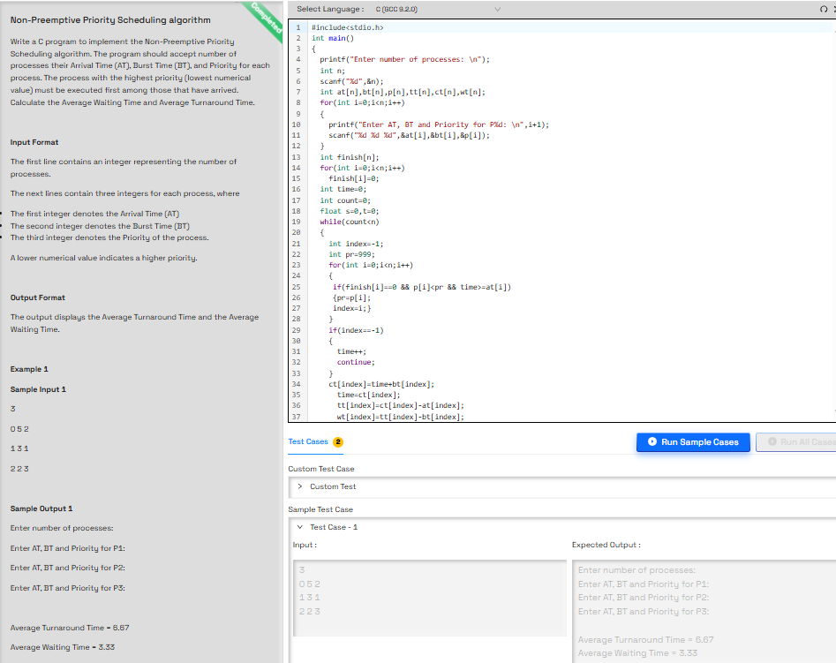
FIGURE: 1.3

1.(d) Round Robin Scheduling Algorithm
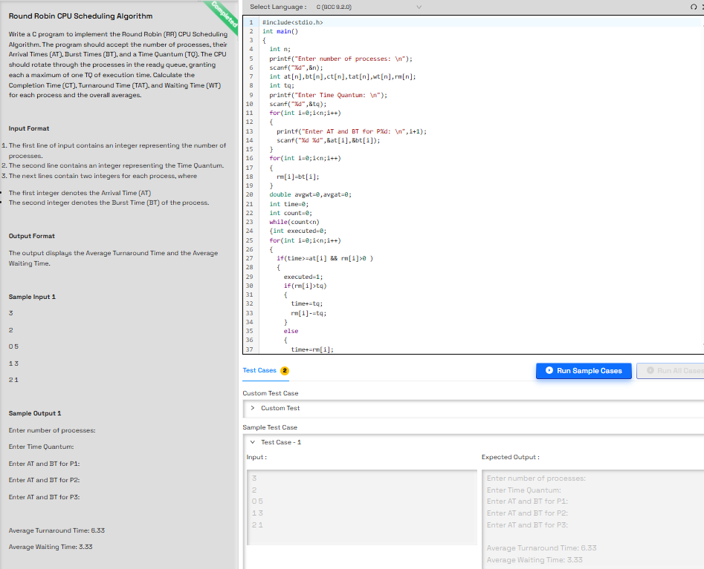
FIGURE: 1.4

EXPERIMENT 02

2) Banker’s Deadlock Avoidance Algorithm
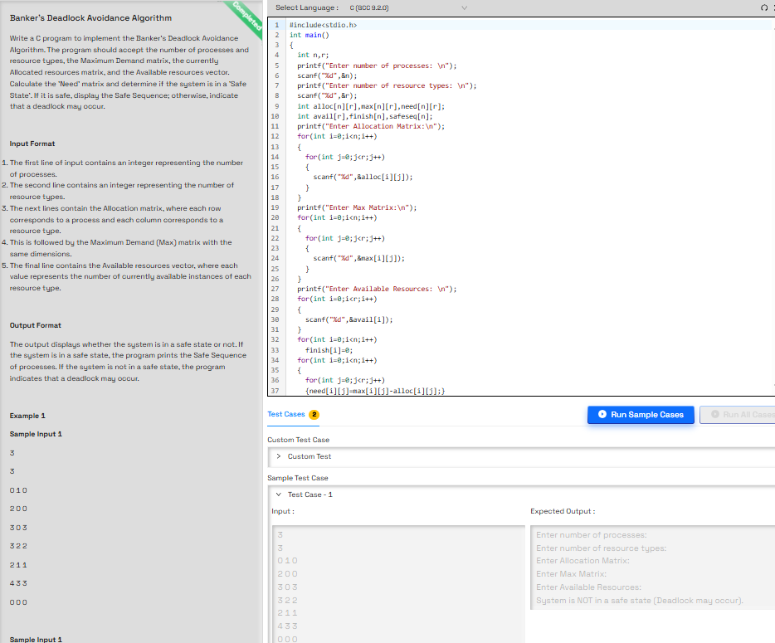
FIGURE: 2.0

EXPERIMENT 03
3.(a)FIFO Page Replacement Algorithm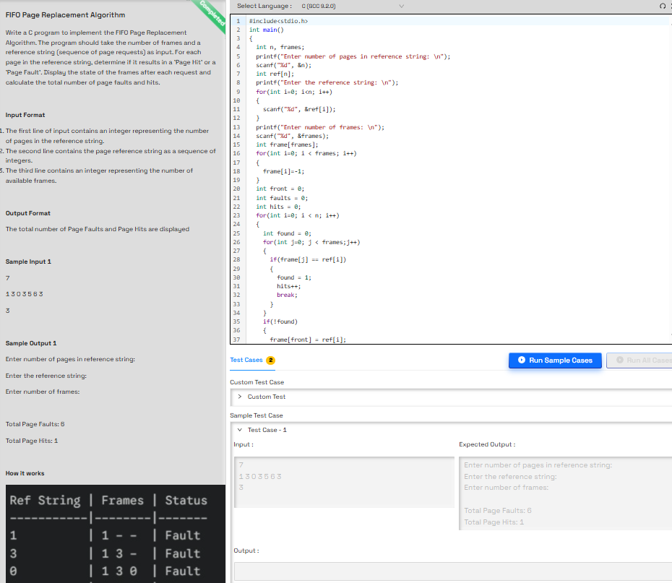
FIGURE:

3.(b) LRU Page Replacement Algorithm
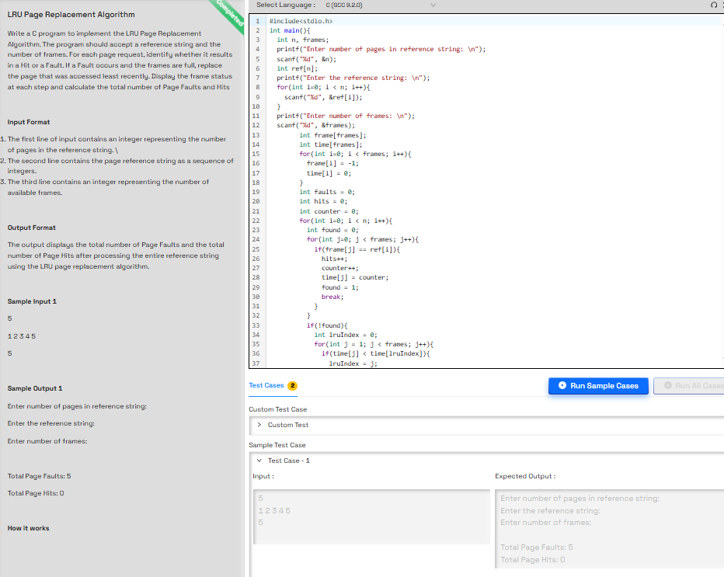
FIGURE: 3.2

EXPERIMENT 04

4.(a)First Fit Contigous Memory Allocation
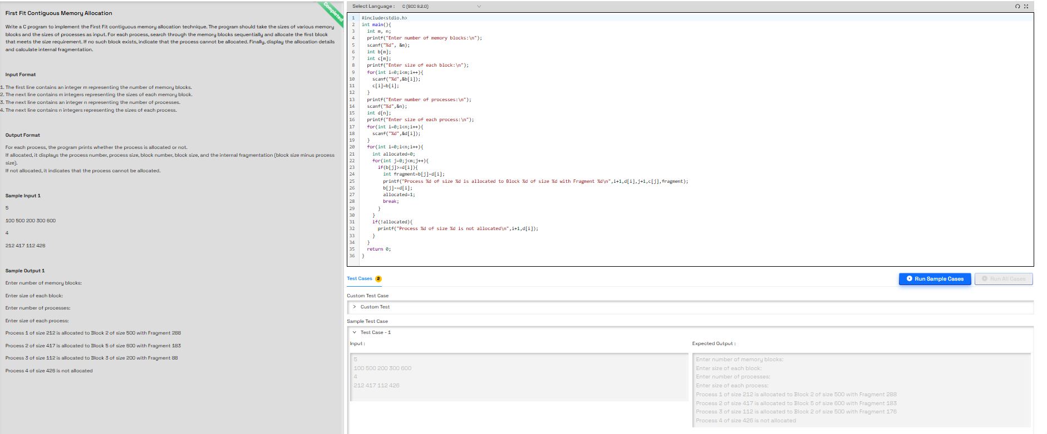
FIGURE: 4.1

4.(b) Best Fit Contigous Memory Allocation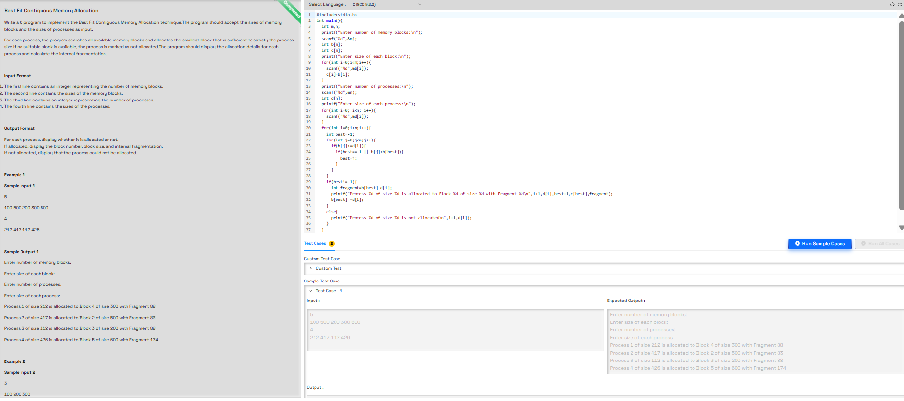
FIGURE: 4.2

